
Serving Box Butte, Dawes, Sheridan and Sioux Counties

430 East Second Street Chadron, Nebraska 69337

Phone 308.432.6190 www.unwnrd.org Fax 308.432.6187 ___________________________________________________________

Crop Water Use Report for the week of July 29, 2024

Over the past week, corn used 2.31 inches.
Expected use by corn for this week is 2.53 inches.

In the past week, beets used 1.74 inches.
Expected use by beets for this week is 1.91 inches.

Over the past week, potatoes used 1.91 inches.
Expected use by potatoes for this week is 2.09 inches.

Over the past week, dry beans used 1.01 inches.
Expected use by dry beans for this week is 1.1 inches.

Over the past week, soybeans used 2.31 inches.
Expected use by soybeans for this week is 2.42 inches.

Over the past week, sunflowers used 2.1 inches.
Expected use by sunflowers for this week is 2.3 inches.

Over the past week, alfalfa used 2.31 inches.
Expected use by alfalfa for this week is 2.53 inches.

In past week, actively growing lawns used 2.1 inches.
Expected use by actively growing lawns for this week is 2.3 inches.

In the past week average ET gage readings were 2.1 inches.

The average rainfall for the district was 0.43 inches.

The weather forecast for the next week shows highs being in the 90’s and lower 100’s and lows being in the 50’s and 60’s. Scattered storms and showers are possible throughout the week.

The crop water use report is completed using the average growth stage for each crop and ET gage reading from across the district. To find the conversion for your specific crop growth stage visit https://nawmn.unl.edu/GrowthStageData

For more information or to inquire about ET gages or soil moisture monitoring equipment, please contact Robbin Randall at the Upper Niobrara White Natural Resources District at 308.432.6190 or visit our website at www.unwnrd.org. We are committed to helping Nebraskans conserve and protect groundwater.

CORN
ET |  | V14 | V16 | R1 Silking
Subarea I | Used | 2.42 | 2.64 | 2.64
 | Projected | 2.53 | 2.75 | 2.75
Subarea II&VI | Used | 2.02 | 2.2 | 2.2
 | Projected | 2.12 | 2.22 | 2.22
Subarea III | Used | 1.72 | 1.87 | 1.87
 | Projected | 1.92 | 2.09 | 2.09
Subarea IV | Used | 2.02 | 2.2 | 2.2
 | Projected | 2.12 | 2.31 | 2.31
Subarea V | Used | 2.32 | 2.53 | 2.53
 | Projected | 2.42 | 2.64 | 2.64

SUGAR BEETS
ET |  | Cover 80 - 90% | Cover 90-Full | Full Cover
Subarea I | Used | 1.44 | 1.75 | 1.99
 | Projected | 1.5 | 1.83 | 2.08
Subarea II&VI | Used | 1.2 | 1.46 | 1.66
 | Projected | 1.26 | 1.53 | 1.74
Subarea III | Used | 1.02 | 1.24 | 1.41
 | Projected | 1.08 | 1.31 | 1.49
Subarea IV | Used | 1.2 | 1.46 | 1.66
 | Projected | 1.26 | 1.53 | 1.74
Subarea V | Used | 1.38 | 1.68 | 1.91
 | Projected | 1.44 | 1.75 | 1.99

POTATOES
ET |  | Early Blossom | Tuber | Tuberization
Subarea I | Used | 1.27 | 1.82 | 2.18
 | Projected | 1.33 | 1.9 | 2.28
Subarea II&VI | Used | 1.06 | 1.52 | 1.82
 | Projected | 1.11 | 1.6 | 1.91
Subarea III | Used | 0.9 | 1.29 | 1.55
 | Projected | 0.95 | 1.37 | 1.64
Subarea IV | Used | 1.06 | 1.52 | 1.82
 | Projected | 1.11 | 1.6 | 1.91
Subarea V | Used | 1.22 | 1.75 | 2.09
 | Projected | 1.27 | 1.82 | 2.18

DRY BEANS
ET |  | Cover 10-50% | Cover 50-80% | Cover 80- Full
Subarea I | Used | 0.14 | 1.15 | 1.94
 | Projected | 0.15 | 1.2 | 2.03
Subarea II&VI | Used | 0.12 | 0.96 | 1.62
 | Projected | 0.13 | 1.01 | 1.7
Subarea III | Used | 0.1 | 0.82 | 1.38
 | Projected | 0.11 | 0.86 | 1.46
Subarea IV | Used | 0.12 | 0.96 | 1.62
 | Projected | 0.13 | 1.01 | 1.7
Subarea V | Used | 0.14 | 1.1 | 1.86
 | Projected | 0.14 | 1.15 | 1.94

SOYBEANS
ET |  | R2 | R3-R5 | Begin Mature
Subarea I | Used | 2.4 | 2.64 | 2.16
 | Projected | 2.5 | 2.75 | 2.25
Subarea II&VI | Used | 2 | 2.2 | 1.8
 | Projected | 2.1 | 2.31 | 1.89
Subarea III | Used | 1.7 | 1.87 | 1.53
 | Projected | 1.8 | 1.98 | 1.62
Subarea IV | Used | 2 | 2.2 | 1.8
 | Projected | 2.3 | 2.53 | 2.07
Subarea V | Used | 2.3 | 2.53 | 2.07
 | Projected | 2.4 | 2.64 | 2.16

SUNFLOWERS
ET |  | Vegatative | Bud Formation
Subarea I | Used | 0.24 | 2.4
 | Projected | 0.25 | 2.5
Subarea II&VI | Used | 0.2 | 2
 | Projected | 0.21 | 2.1
Subarea III | Used | 0.17 | 1.7
 | Projected | 0.19 | 1.9
Subarea IV | Used | 0.2 | 2
 | Projected | 0.21 | 2.1
Subarea V | Used | 0.23 | 2.3
 | Projected | 0.24 | 2.4

ALFALFA
ET
Subarea I | Used | 2.64
 | Projected | 2.75
Subarea II&VI | Used | 2.2
 | Projected | 2.31
Subarea III | Used | 1.87
 | Projected | 1.98
Subarea IV | Used | 2.2
 | Projected | 2.31
Subarea V | Used | 2.53
 | Projected | 2.64

 | GRASS
ET
Subarea I | Used | 2.1
 | Projected | 2.3
Subarea II&VI | Used | 2.1
 | Projected | 2.3
Subarea III | Used | 2.1
 | Projected | 2.3
Subarea IV | Used | 2.1
 | Projected | 2.3
Subarea V | Used | 2.1
 | Projected | 2.3

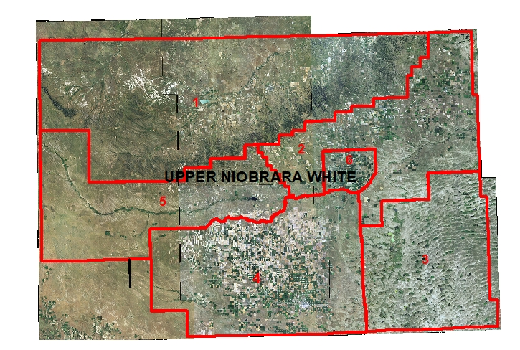
UNWNRD Subarea Map

